Vrixzandro Cunamay Eliponga System Administration and Maintenance

BT1203 02 Laboratory Exercise 1

1. Result of install gcc, emacs, and httpd

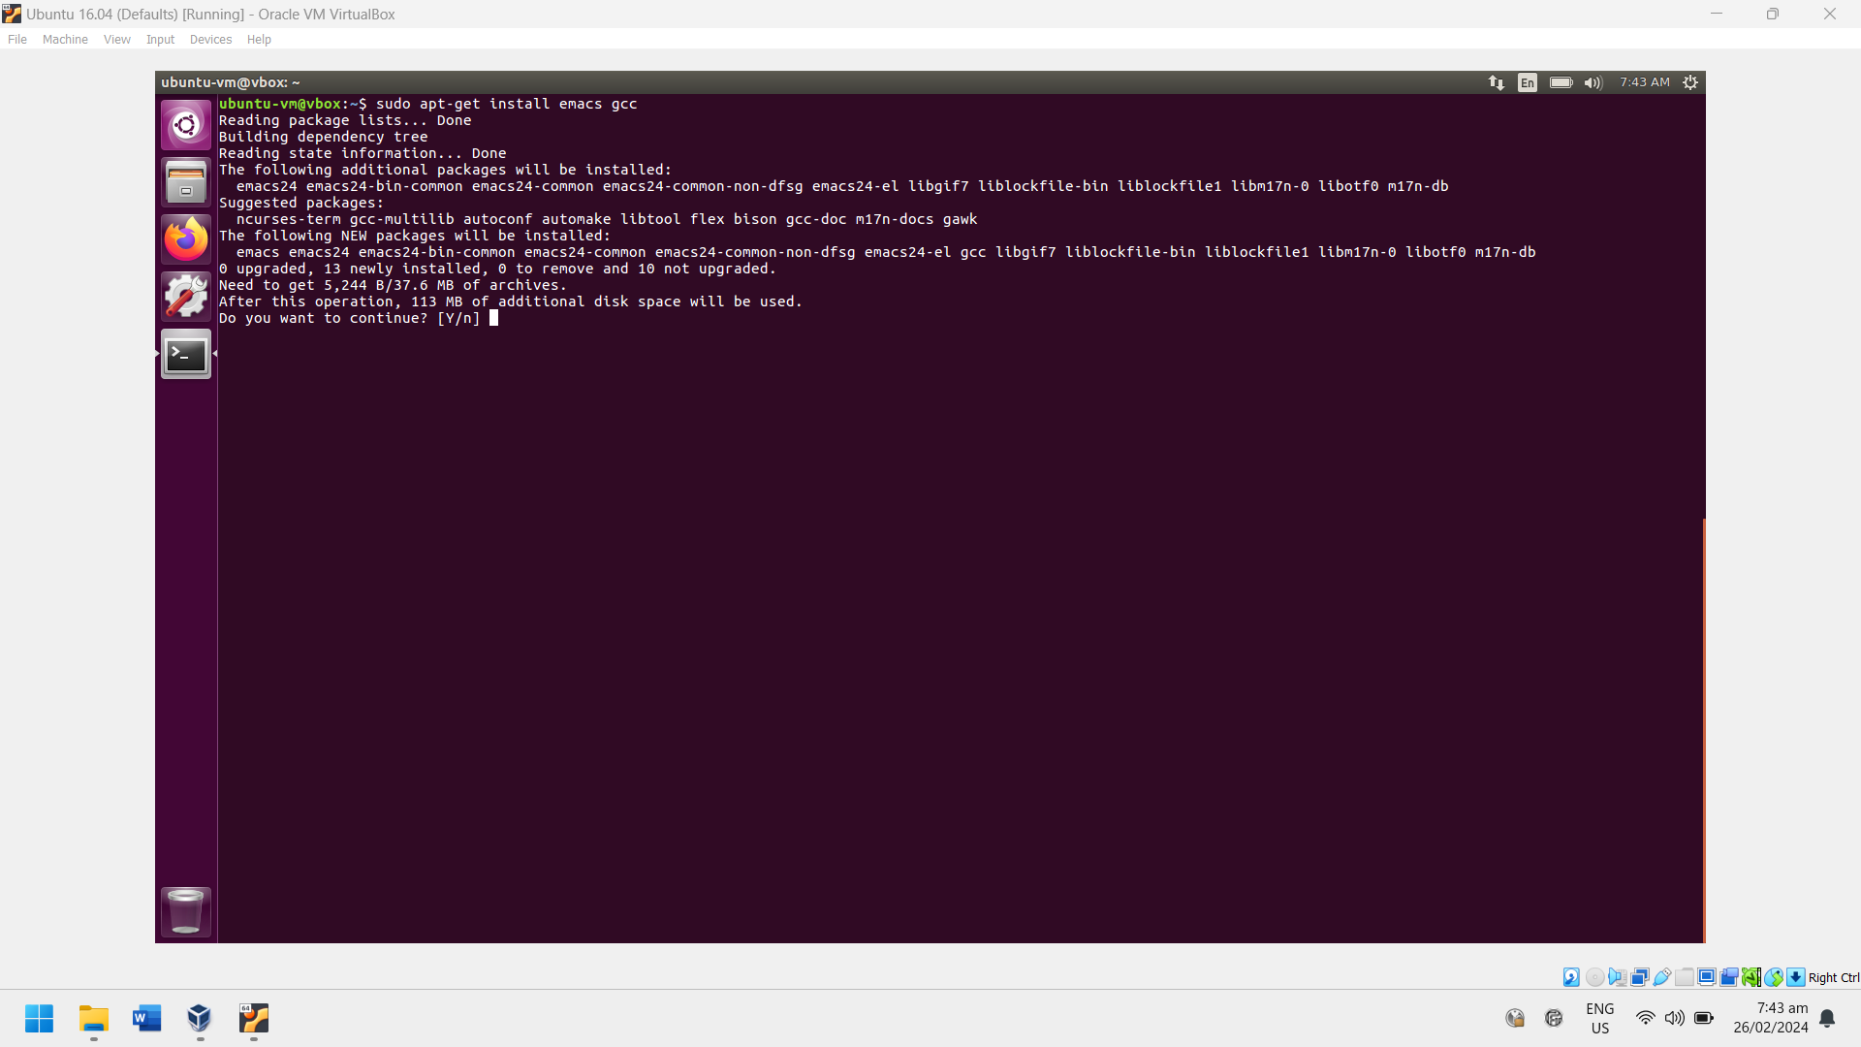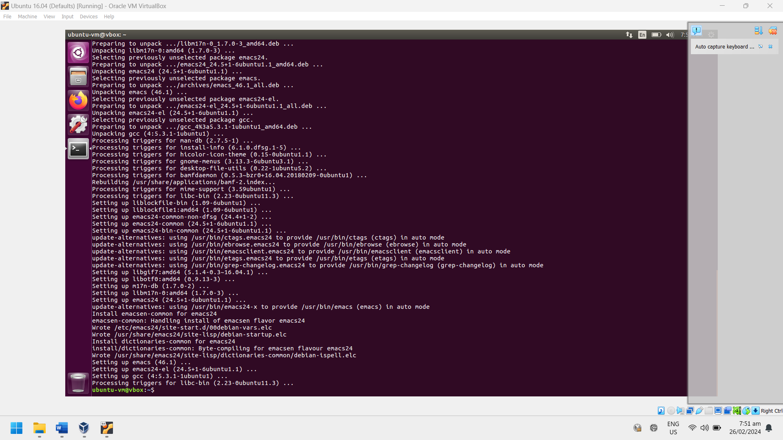

1. Result of the update command for gcc, emacs, and httpd

1. Result of the update command (no specified package)

1. Result of the remove command for gcc, emacs, and httpd

